RUNClub Trips 2017
Kelowna BMO & VEGAS Rock N Roll 5K/ 10K/ Half Marathon.
Planning event fee covers until January 2018
Kelowna Race Day: Sunday October 8th 2017
VEGAS Race Day: Sat Nov 11th/ Sun November 12th 2017
The 5K is on Saturday Nov 11th / All other distances Sun Nov 12th
RUNCLUB Event Planning fee: Paid no later than July 1st 2017.
• Vegas $100.00 per person | $150.00 per couple (Vegas)
• Kelowna $20.00 each

Includes everything below and more up until January 2018
RUNClub is much M-O-R-E than running!
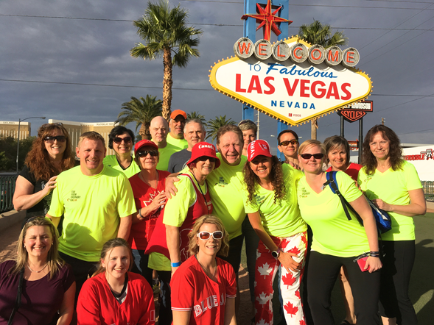
Non-running spouses, friends, and family invited. They are invited to all planned activities (no charge).

Your Destination RUNClub Experience includes;

- Full agenda & LIFETIMEMEMORIES

- LIFETIME FRIENDSHIPS

- Email Club/ personal communication

- Photos (pre run/during run/ post Run)

- Party and Pub planning nights in KAMLOOPS leading up to RACE DAY☺☺☺☺

- PLANNING FOR Kelowna pre dinner and VEGAS Post Party Dinner (your food and alcohol not included).

- VEGAS Start line/ finish line support and CELEBRATION!

- Wrap up Party Kamloops-­‐-­‐-­‐ January 2018 ……and much M-­‐-­‐-­‐O-­‐-­‐-­‐R-­‐-­‐-­‐E!

Event and Travel Info: Las Vegas Rock N Roll weekend November 12th 2017 Suggested day(s) to stay -­‐-­‐-­‐ (Vegas):
- 5 nights – Thurs. Fri. Sat. Sun. Mon

- 4 nights -­‐-­‐-­‐ Fri (Early flight). Sat. Sun. Mon.

- 3 nights – Fri (Early flight). Sat. Sun. Hotels

- My recommendation (and where I love to stay in Vegas): The MGM Signature Suites. They have full kitchens/ Coffee Makers and a pool (fun for hot tubing etc ( 4-5 star)
- If you want to be 4 blocks from the start line: Mandalay Bay ( 4-­‐-­‐-­‐5 Star)

- Flamingo – is a traditional Vegas Hotel on the strip (3 star)

- Please check out the Vegas Rock N Roll website to see the hotels in vicinity to the start line. That being said, the race is at night (super cool) and lots of time to get to the start line.
Flights: please book your own flights. Everyone has different preferences on costs, air miles, and days. I have flown out of Kamloops / Kelowna/ Bellingham and Seattle. Once you have a flight in mind, please share with the group (will start a Facebook page).

Kelowna BMO:
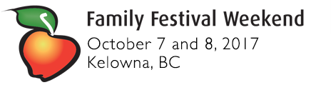
$20.00 Event Planning Fee. No charge for spouses/ friends.
Race Days: Sunday October 8th ‐-­‐-­‐ 10K / 21K and Full Marathon
Stay over Saturday October 7th – Home Sunday October 8th
(Optional RUNClub FAMILY DINNER - celebrate together Sunday night – Thanksgiving dinner @ the Berrypatch).
Hotels: Please check the Kelowna website for more suggestions as well.
Delta – 5 star (This is where I will be staying – if we want I can look into the residences and sharing).
Days Inn - 3 star
Pre-race dinner Saturday night. Post party 2018

**** TSHIRTS – There will be awesome, fun team shirts for both events (extra charge) ****

